Transplant Volumes and Disparities: A Data Analysis of U.S. Organ Allocation

(2018 to 2025)

By: Sumaiya Tasnim
August 2025

Summary:
This paper looks at organ transplant volumes and waiting-list data in the U.S. between 2018 and 2025 to get a clearer sense of who actually receives a transplant and who is left waiting. Transplant numbers grew for almost every group over this period, but the gap between groups never really closed, and some patients consistently received far fewer transplants, including living-donor transplants, year after year. Race does seem to line up with these gaps to some extent, but the data here point to something else doing a lot of the work: everyday socioeconomic pressures like household income, insurance coverage, whether someone can take unpaid time off for an evaluation appointment or a donor surgery, whether they are the only earner in their household, dependable transportation, and how far they live from a transplant center. Getting an organ is not only about medical compatibility; a patient also has to stay reachable, keep appointments, and be able to travel on short notice once a match comes through, and that is exactly where financial and logistical strain can knock someone out of contention no matter their race or ethnicity. What follows walks through the trends in the data, considers a few possible explanations, and is upfront about where this analysis cannot tell race and socioeconomic status apart without more individual-level information. Answering that fully would take further research that asks patients directly about their circumstances.

Introduction:
Organ transplantation can save the life of someone with end-stage organ failure, but not everyone who needs one gets the same shot at receiving it. Hundreds of thousands of people are added to the U.S. waiting list every year, and a new name joins that list roughly every eight minutes now, up from every eleven minutes back in 2016. By the middle of 2025, more than 103,000 men, women, and children were still waiting. Doctors performed over 48,000 transplants in 2024, which sounds like a lot until you consider that demand keeps climbing faster than supply. On average, 13 people on the waiting list die every day before an organ becomes available to them.
Qualifying as a donor is not automatic. It depends on age, medical history, and family history, and even candidates who clear those hurdles still need further testing to make sure their body will not reject the organ. Race and ethnicity sometimes enter the picture here too, since genetic and immunologic markers can affect compatibility. That does not mean donor and recipient need to share a race or ethnicity; cross-racial matches happen all the time. What does help is a bigger, more diverse donor registry, because it raises the odds that everyone on the list, including people with less common genetic markers, can find a match. A lot of prior research has already documented gaps in transplant access by race, ethnicity, age, and donor type, but those gaps are still not well understood once you start tracking them across years and across different groups of patients. That is the gap this study tries to fill, using data from 2018 to 2025 to track transplant volumes, the split between living and deceased donors, and who ends up on the waiting list. Using R and ggplot2 for the statistical work and the visualizations, the goal here is simply to get a clearer read on who is waiting, who is receiving transplants, and how that has shifted over time, since a clearer picture is the first step toward better policy and more equal access.

Methods:
This study draws on publicly available transplant data from 2018 through 2025, covering transplant volumes by race and ethnicity, donor type (living or deceased), patient age group, and the size of the waiting list. All of the data cleaning happened in R, where the original tables were reshaped into tidy data frames that were easier to work with. From there, averages, maximums, minimums, and standard deviations were calculated for transplant counts across the different racial and ethnic groups, and functions like mutate were used to track year-over-year percentage changes.
Ggplot2 did the heavy lifting for visualization, building the line plots, faceted charts, and summary graphics that show transplant activity by year, donor type, and race. Waiting-list totals were also compared against actual transplant rates to see where supply and demand were most mismatched, and the analysis looked at whether social or demographic factors seemed to line up with the disparities in the data. Before finalizing any of the charts or summaries, the data was checked again for errors and inconsistencies. The goal across all of this was to build an honest picture of how transplant volumes have changed, who is still waiting, who is actually receiving care, and where the system is falling short.

Results:
Transplant volumes climbed steadily across every racial and ethnic group between 2018 and 2024, which is a genuinely encouraging trend, likely tied to improvements in donor availability and medical infrastructure. Then in 2025, the numbers dropped sharply across the board, and it is not entirely clear why. The most likely explanation is simply that the 2025 data is incomplete, since the year had not finished by the time this analysis was done. Large health datasets often show this kind of dip in the most recent year just because of reporting lag, not an actual decline. Changes to reporting systems or disruptions in healthcare delivery could also be playing a role.
There is a smaller dip in 2020 as well, almost certainly tied to COVID-19. Hospitals were stretched thin, elective procedures got paused, and transplant surgeries were delayed because of safety concerns, limited ICU capacity, and the risk of exposure. Volumes bounced back in the years after, and 2019 actually stands out for strong year-over-year growth among Black and Hispanic/Latino patients specifically, which suggests access was genuinely expanding for a while. Still, the 2025 dip is a good reminder that transplant data needs to be read with some caution when the reporting window has not fully closed yet.

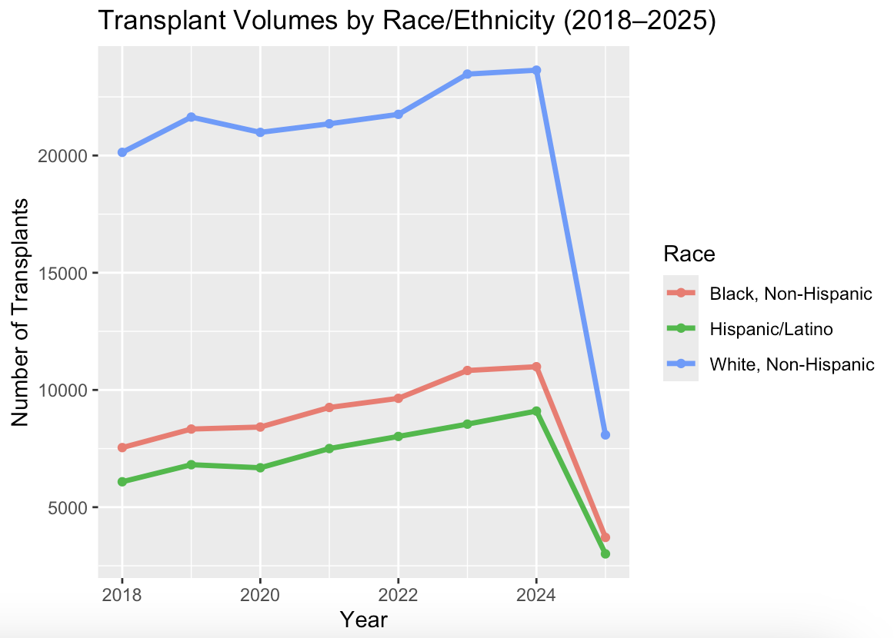
Figure 1. Transplant volumes by race from 2018 to 2025. All groups experienced steady growth in transplant numbers until a noticeable drop in 2025.

Across the full study period, the gap between groups never closed. White, Non-Hispanic patients averaged about 20,133 transplants a year, more than double the roughly 8,590 a year that Black, Non-Hispanic patients averaged, and well above the 6,968 a year for Hispanic/Latino patients. That gap held steady in every year of the data. White patients also showed the most year-to-year variation, with a standard deviation of 5,011, which could mean their access is more responsive to changing conditions or that their donor networks simply have more capacity to flex. Transplant volumes for Black and Hispanic/Latino patients, by contrast, stayed both lower and more stable, which points less to random variation and more to a fairly fixed set of barriers. Read together, these are not just statistics; they line up with everyday factors like income, job flexibility, and dependable transportation that can make it harder for some patients to get the same access to care.

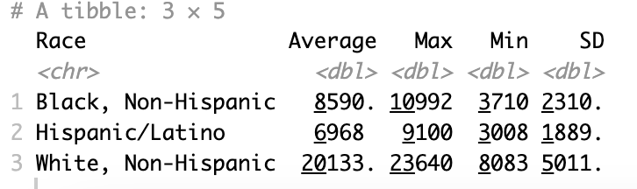
Figure 2. Statistical summary of transplant counts by race and ethnicity, showing the average, maximum, minimum, and variability over the study period.
Deceased donor transplants made up the majority of procedures across every group, and that reliance was strongest for White, Non-Hispanic patients, who received roughly 16,228 deceased-donor transplants a year on average, nearly double the number for Black and Hispanic/Latino patients. Living donor transplants tell a similar story on a smaller scale: White, Non-Hispanic patients averaged 3,905 a year, compared to 719 for Black, Non-Hispanic patients and 1,040 for Hispanic/Latino patients. Those numbers probably have less to do with willingness to donate and more to do with what donating actually requires: unpaid time off work for surgery and weeks of recovery, reliable transportation to and from a transplant center, and enough of a financial cushion to get through the lost income. If someone is the only working adult in their household, or does not have paid leave or a dependable way to get to appointments, donating simply is not realistic no matter how willing they are. Limited access to donor networks and health education, plus eligibility issues tied to existing health conditions, likely shrink the donor pool further for people already dealing with these pressures. Put together, the gap in both deceased and living donor access widens the overall inequality and raises real questions about how fair and accessible the system actually is.
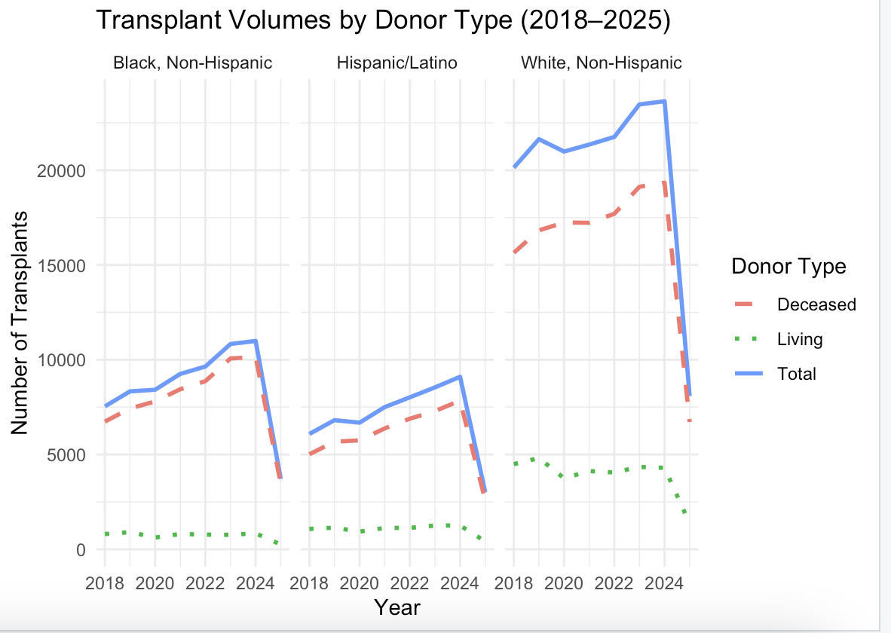

Figure 3. Breakdown of transplants by donor type (deceased vs. living) and race/ethnicity between 2018 and 2025. Deceased donors accounted for the majority of transplants across all groups.
Looking at each year's share of total transplants tells the same story. White, Non-Hispanic patients consistently received the largest slice, even though Black and Hispanic/Latino patients made up a substantial share of the waiting list. That mismatch is not just a population effect; it points to something in how organs get allocated and who ends up receiving them. The need for transplants exists across every community, but access to them clearly does not. Year after year, White patients received the majority of transplants while other groups stayed underrepresented in the totals, and that pattern suggests structural factors, like socioeconomic status, access to healthcare, referral rates, and the availability of living donors, are shaping outcomes more than need alone. It is worth digging further into what is driving that gap so the system can actually be made more equitable.

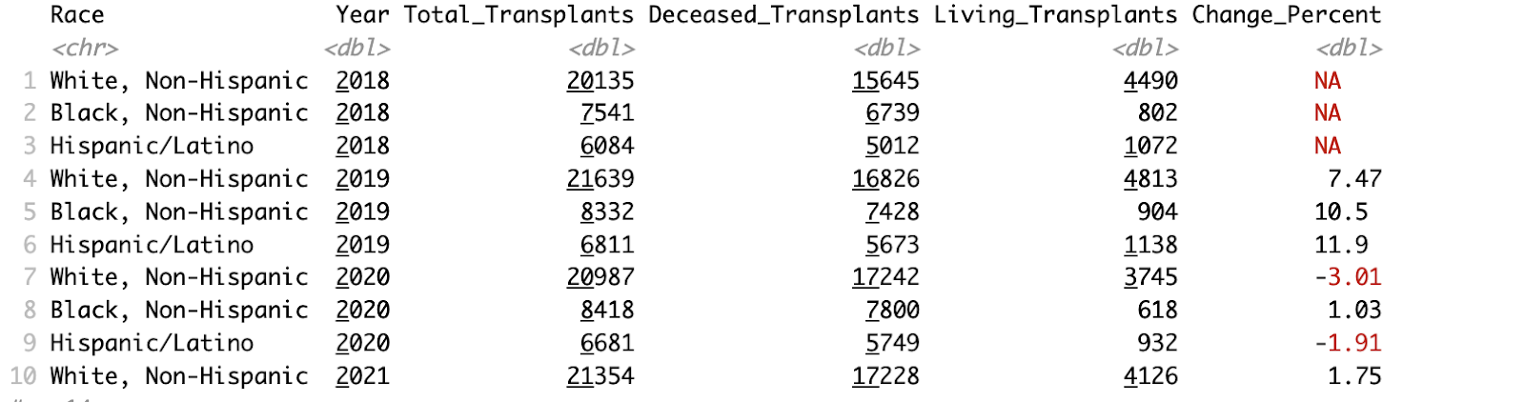
Figure 4. Yearly share of total transplants by race. White, Non-Hispanic patients consistently received the largest percentage of transplants each year.

As of September 2024, most people on the national waiting list were adults between 50 and 64, a group of 43,829 people, with those 65 and older not far behind at 26,460. That tracks with the fact that organ failure becomes more common as people age and develop chronic conditions. Children make up a much smaller share of the list, fewer than 1,000 patients under 18, even though younger patients can face equally life-threatening conditions. Organ failure clearly weighs more heavily on older adults, but it is a concern at every age.
Breaking the waiting list down by race using 2023 data, White patients were the largest group at 40,476, followed by Black patients at 28,552 and Hispanic/Latino patients at 23,757. Those numbers roughly track broader population demographics, but the more telling gap is between how many people are waiting and how many actually get a transplant. Black and Hispanic patients make up a large share of the waiting list, yet their odds of actually receiving a transplant are lower than that share would suggest. That raises a real question about whether the system serves everyone equally, or whether everyday circumstances, unreliable transportation, inflexible work schedules, the financial hit of being a household's only earner, make it harder for some patients to go from being listed to actually receiving the care they need to survive.

Discussion:
Taken as a whole, the results point to a real and lasting gap in transplant access in the United States. Volumes grew for every major group between 2018 and 2024, which looks good on the surface, but some groups consistently received far more transplants than others every single year. This was not a small or one-off difference; it was large and it repeated annually. Population size and health needs alone do not explain that, which points instead to everyday circumstances outside the hospital, income, job flexibility, transportation, caregiving duties, as the more likely drivers of who actually gets access to care. Race tracks with this pattern to some degree, but race by itself does not explain why it happens; the more direct cause is probably the practical, day-to-day barriers this study keeps coming back to, barriers that just happen to land unevenly across different communities. Figuring out exactly how much each factor matters would take further research that looks at individual patients' circumstances rather than broad demographic categories. Whatever the exact cause, a gap this consistent is a failure of equity in one of the most critical corners of medicine.

Donor type adds another layer to this. Deceased donors accounted for most transplants across every group, but the living-donor gap was even more pronounced: White, Non-Hispanic patients received nearly four times as many living-donor transplants as Black or Hispanic/Latino patients. That is a meaningful difference, since living-donor transplants tend to come with better outcomes and shorter wait times. The lower numbers for Black and Hispanic patients almost certainly are not about a lack of willingness to donate. It is more likely the same pressures showing up again: lacking health insurance or access to transplant education, the financial strain of unpaid time off, which hits hardest when someone is their household's only earner, and a higher chance of health conditions in close family members that rule out potential donors. These are public health and economic problems as much as medical ones, and fixing transplant inequity is going to mean looking well past the hospital walls.

Understanding Access: Structural and Socioeconomic Barriers
Getting a transplant comes down to a mix of medical and logistical factors, together deciding who receives what's often called 'the gift of life.' Compatibility, blood type, tissue and antibody matching, organ size, time on the waiting list, is the clinical backbone of how organs get allocated. But medical compatibility by itself does not guarantee anything. Patients also need to stay reachable, get through a long list of pre-transplant evaluations, show up for follow-up appointments, and be ready to travel to a transplant center on short notice once a compatible organ turns up. None of that is strictly medical, and that is exactly where socioeconomic circumstances start to quietly shape who actually gets a transplant.
Picture two patients who are clinically identical in every way that matters: same blood type, same tissue match, same waiting-list score, same diagnosis. If a compatible organ comes up, both are equally eligible in theory. But say one has a reliable car, paid time off, and lives a short drive from the transplant center, while the other does not have consistent transportation, cannot afford to miss a shift, or lives hours from the nearest program. Only one of them can realistically respond in time. The second patient might miss evaluation appointments, drop out of active waiting-list status, or simply be unreachable when the call finally comes, not because of anything medical, but because of circumstances entirely out of their hands. Financial stability and reliable transportation end up acting like a second gatekeeper, sitting right alongside, and sometimes overriding, medical compatibility itself.
That is an important distinction, because it changes how to read the disparities in this study. Race by itself has nothing to do with whether someone can get to an appointment or reach a hospital in time. What the data more likely reflect is that race in the United States still correlates heavily with income, insurance access, how close someone lives to a transplant center, and how reliable their transportation is, all things that can actually be addressed. Framing the problem around those structural and economic factors, rather than race on its own, points toward solutions that would actually help: transportation and lodging assistance for patients and caregivers, more regional transplant centers, and more flexibility built into the evaluation and follow-up process for patients who are already stretched thin.
None of this means race plays no role; there is clearly some correlation in the data here. But race alone does not explain the mechanism behind these gaps. Getting a real answer would take research that asks patients directly about their circumstances, household income, whether they are the only working adult in their family, whether they have paid leave, how reliable their transportation is, to see how much of the disparity actually comes down to race versus these everyday realities.
One of the more striking shifts in the data is the sharp drop in transplant volumes across every group in 2025. It's too early to say for sure why, but the most likely explanations are incomplete data collection, reporting delays, or simply that the year hadn't finished by the time this study was done. Even so, it's a useful reminder of how fragile the transplant system can be. A pandemic, an administrative delay, a reporting gap, any disruption to the normal flow can ripple out and affect thousands of people who are depending on that system to survive. That's part of why it makes more sense to look at trends across several years rather than judge the system by any single year's numbers. The bigger, more consistent story here is one of long-standing inequality and a healthcare system that keeps falling short of providing equal care.
Sample size matters for how much confidence to put in any of this. Pooling several years of data smooths out random swings, like the dip in 2020, and makes the underlying trend easier to read. That's part of why the 2025 decline is treated cautiously here rather than as a confirmed shift, since it's based on a partial, likely incomplete year. But a bigger sample doesn't fix bias that's already baked into how the data was collected or reported. If certain regions or populations are consistently underrepresented for structural reasons, adding more years of the same kind of data will just make that same skewed pattern look more statistically solid, not more accurate. A bigger dataset can make a trend look more certain without telling you whether the process behind it was ever fair to begin with.

Limitations:
This analysis has real limits. The dataset does not include individual-level details like household income, insurance coverage, job flexibility, distance to the nearest transplant center, or access to transportation, so there is no way to directly test whether these socioeconomic factors are actually driving the patterns here, only that they are plausible and worth digging into further. It also does not capture referral rates, so there is no way to tell how many patients were evaluated for a transplant but never made it onto the waiting list in the first place, which is an earlier point where disparities could easily start. Individual-level clinical severity and comorbidity data were not available either, so differences in medical urgency between groups could not be fully accounted for. The 2025 data reflects only a partial year and should be read cautiously rather than as a settled trend. And because this analysis relies on national, aggregated numbers, it can miss meaningful variation across the country's regional organ allocation zones, so local disparities in a given state might look quite different from the national picture presented here. All of this means the data clearly show unequal outcomes, but they cannot pin down the exact cause behind them on their own.

Conclusion:
What this study makes clear is that access to organ transplantation in the U.S. still is not equal. Transplant volumes have grown overall, but that growth has not been distributed evenly, in deceased donor cases or living donor cases. Black and Hispanic/Latino patients make up a large share of the waiting list, yet they consistently receive fewer transplants than that share would predict.
Closing that gap is not just a matter of recruiting more donors. It means addressing the everyday, practical barriers, income, job flexibility, transportation, caregiving responsibilities, that keep many patients from getting a fair shot in the first place. Race clearly plays some part in these outcomes, but figuring out how much of that is really about race versus the life circumstances that happen to hit some communities harder would take research that asks patients directly. If the goal is a system that actually serves everyone, reporting these trends is not enough; it has to lead somewhere. That means moving from awareness to accountability, and from collecting data to actually improving access.

References
Detailed Description of Data | organdonor.gov. (2024, October 17). Organ Donation. Retrieved August 3, 2025, from https://www.organdonor.gov/learn/organ-donation-statistics/detailed-description#fig1
Detailed Description of Data | organdonor.gov. (2024, October 17). Organ Donation. Retrieved August 3, 2025, from https://www.organdonor.gov/learn/organ-donation-statistics/detailed-description#fig2
Organ Transplants and Black/African Americans | Office of Minority Health. (2025, February 13). Office of Minority Health (OMH). Retrieved August 3, 2025, from https://minorityhealth.hhs.gov/organ-transplants-and-blackafrican-americans
Racial and ethnic disparities on the heart transplant waiting list. (2025, March 15). PubMed. Retrieved August 3, 2025, from https://pubmed.ncbi.nlm.nih.gov/39814184/

